**Visual Programming**

**Lab Journal - Lab 10**

Name: _________________________________

Enrollment #: _________________________________

Class/Section: _________________________________

**Objective**

The Objective of this lab are to understand the following concepts

* Exception Handling
* Input Validation

**Task 1 :**

Write the Implementation of the following design mentioned below.

**Form 1:**

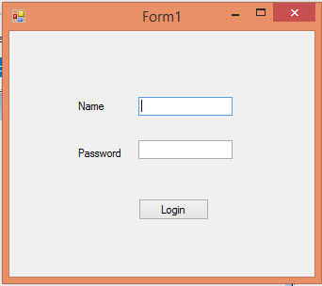

**Form 2:**

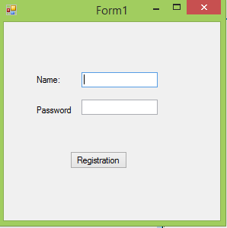

**Form 3:**

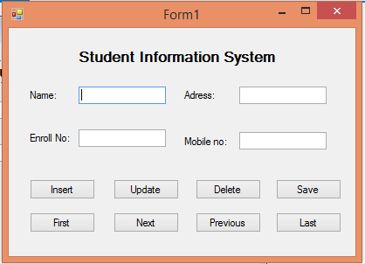

**Description of Form 1:**

The Form 1 ask the user to input Name and Password for login into the system. the Name and Password will be matched with the Names and passwords that will store while registration of the user if the name and password are correct it will directly move you towards the form 3 which is basically the “Student information System” otherwise it will prompt the error “ Name or password is incorrect “.

**Description of Form 2:**

At the beginning the program ask the user to input Name and Password for Registration. Perform input validation on the Name Textbox and Password Textbox. For Password textbox the password should not be less than 8 characters string. The password’s 3rd character will be special character like ‘@’ , $’ ,’%’ and 7th character will be an integer character like 0,1,2,3 …. 9 remaining characters you can choose from the mixture of alphabetic characters, Special characters and numbers. If the pattern of the password is not correct it will throw an Exception of “Your Pattern of password is, 3rd character will be special character like ‘@’ , $’ ,’%’ and 7th character will be an integer character like 0,1,2,3 …. 9 remaining characters you can choose from the mixture of alphabetic characters, Special characters and numbers”.

**Description of form 3:**

Once you will reach at Student information System you will see a lot of Buttons the functionality of each button is mentioned below

1. **Insert Button:**

Insert button will insert the record on ArrayList Only. Tackle the runtime error while adding the record in ArrayList with Exception Handling.

1. **Update Button:**

Update button will update the record of the student. It will prompt the user whether to update the record in Senior Student file or Junior student file in a new form. It will update the record with respect to “Enrollment Number”. If the record is not found print “Record not found on the Dialog Box”. Perform Exception Handling while updation of the data in “Junior Student file” and “Junior Student File”.

1. **Delete Button:**

Delete Button will delete the record from the student information System. It will prompt the user whether to update the record in Senior Student file or Junior student file. It will delete the record with respect to “Enrollment Number”. It will also remove the record from the text file which will be Senior Student file or Junior Student file and from the Array List If not empty or its depend on the availability of the record in an Array List. If the record is not found print “Record not found on the Dialog Box”.

1. **Save Button:**

Save Button will directly save the record on the text file like Junior Student File or Senior Student File. If the Enrollment number starts with ‘1’ it will considered as Senior Student otherwise it will be Junior Student. It will also prompt how many number of record you have saved in any of the file. Perform Exception Handling while saving the record in “Junior Student File” or “Senior Student File”.

1. **First , Last , Next and Previous Buttons:**

Remaining buttons will display the record on the form in either from Senior Student file or Junior Student file. Tackle Eception Handling while displaying First, Last, Next and Previous record from the files.